Cecilia Sparks

Dr. Banks

ENGL 8600

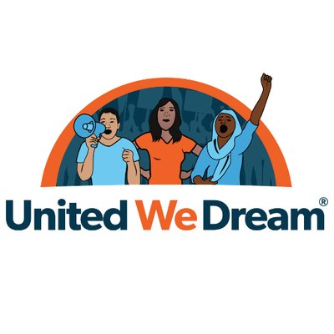06 November 2018

United We Dream: Spreading the Message to Dreamers Through Digital Literacies

First, it is important to understand the history of immigrants (and immigration) in the United States. According to Jamie Candelaria Green, in the Americas, as early as the 1500’s, “the Spanish were responsible for many literacy firsts” (the Roman alphabet), such as births, deaths, marriages, reading and grammar texts, plays, schools, musicals, maps, petitions, commissions, edicts, inventories, contracts, and ledgers ( 237). Not until the 1600’s did European literacy begin. So, as a nation that often sees the Spanish speaking (Hispanic) immigrants as subordinates, if what Green says is true, then this country owes a small acknowledgement to those who were here before us. To take it one step further, Heather Silber Mohamed reports that “Under the 1848 Treaty of Guadalupe Hidalgo, Mexico ceded to the United States the territory that now constitutes California, Nevada, and Utah, as well as parts of Arizona, New Mexico, and Wyoming”… and residents who were already living there had the choice to stay in the newly acquired United States properties or move downward into Mexican territory. Of those residents, close to 75,000 stayed and pursued citizenship (45). However, it was not without discrimination or violence toward them. In addition to that, Mohamed breaks her information into time frames of social (Latino) movements, explaining that since the early 1900’s, the messages and defining characteristics of organizations followed an ebb and flow process, starting with documented immigrant citizens embracing assimilation, patriotism, and the English language (and frowning on those who did not); to the 1960’s and 70’s and the embracing of cultural differences, nationalism, and holding on to the Spanish language and heritages for Latino immigrants; to the 80’s and sanctuary movements; to the 90’s where it shifted back and forth many times, depending on the movement, and consequently breaking the violence (secondary marginalization and “selective dissociation”) that happens by the division of smaller counterpublics within larger counterpublics (One Latino Family); up until 2006 when the protests moved back toward Americanization, being American, and flying American flags and showing patriotism, including immigration reform and the rights of the undocumented (Mohamed table 3.1, Pp. 51). By and large, the vast majority of undocumented immigrants are honest, well-intentioned, and family-oriented individuals looking to do their best for their families and their futures. They have certainly earned the right to be humanized rather than ostracized, criminalized, or condemned to death” (Davies 388).

Now, with further inspection into the American educational system, it quickly becomes clear that there is a violence of literacy placed on the undocumented. Forcing an undocumented child to go to school, to learn to read and write in English, for nothing more than making them “good, appropriate citizens,” is a disservice to each and every undocumented child who graduates from high school but cannot secure employment because he or she is in fact, illegally in the United States. It is a violence toward the undocumented, a violence that controls through fear and illiteracy. This violence may not be in the terms that Elizabeth Stuckey defines it (literacy is a system of oppression that works against entire societies as well as against certain groups within given populations and against individual people [64]), but it is there, keeping the minority from ever successfully improving life. And, this type of violence, this lack of education, serves a dual role: it leads to” culture loss” and the “sense of not belonging in an unfamiliar and hostile world” (Davies 386).  According to the Department of Education, 65,000 undocumented immigrants graduate from US high schools each year (Resource guide 3). It only seems fair, that they be able to apply for and keep DACA (Deferred Action for Childhood Arrivals) so that they can contribute to society as legal citizens.

My purpose for this project is to examine the website *UnitedWeDream.org* (UWD) and determine how it sponsors literacy for the undocumented (and documented) immigrants in both the United States and globally to help alleviate the exigency of the undocumented immigrant (specifically in the USA). The DREAM (Development, Relief, and Education for Alien Minors) Act was first introduced to congress in 2001, and since then, undocumented immigrants have been called *dreamers* (AmericanImmigrationCouncil.org). The purpose: to create a pathway to legal status for innocent, undocumented children brought to the USA from another country. The undocumented young who were brought here illegally should not be punished and taken away from the only “home” they know. This is their country. In 2012, President Obama announced the DACA program to further support and protect undocumented youth, stating, “It is the right thing to do”… *dreamers* are “Americans in their hearts, in their minds, in every single way but on: on paper” (AmericanImmigrationCouncil.org). However, this specific group has faced an enormous amount of scrutiny and racism since they have arrived. Although they grow up here, go to school here, and identify with the United States, they are not US citizens.  The undocumented youth are caught between the borders of their homelands and this country. They cannot go back to their own country, and they do not know how to legally stay in the United States. Thus the creation of United We Dream: using immigration as a tool of social justice and change.

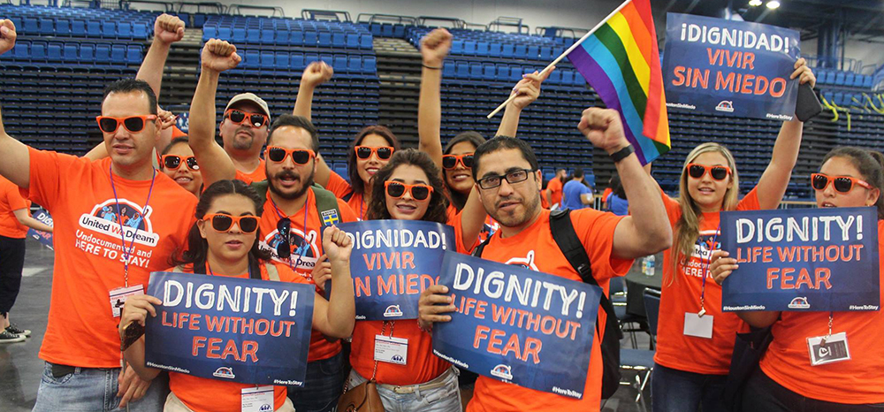

United We Dream (UWD) is a youth-led, online organization and the largest immigrant community in the United States of America. The multimedia, multiliteracy, website was created by both documented and undocumented immigrants to create a space for the voices of both groups to be heard. UWD’s purpose is to empower and support not just minority immigrants, but all immigrants, including immigrant women and the LGBTQ immigrant groups who have faced the most scrutiny in this country, through sponsoring civil and legal literacy to those who need it the most. Additionally, UWD’s purpose is to disrupt the traditional notions of literacy by offering multiple avenues of collaboration and communication for those who, otherwise, would not have had the opportunity of inclusion into society. According to the website, through the use of digital media, United We Dream has

reached over 4 million people, has over 400K members, 5 statewide branches, and 100 plus groups across 28 of the 50 states. In addition, more than 60% of the members are women, of which 20 % identify as LGBTQ. The online, global community began in 2015 with the purpose of allowing undocumented immigrants of all diversities to take control of their own destinies by giving them the space, knowledge, and ability to empower themselves (and the people around them) to fight for social justice so that they can stay in this country.

As human rights advocates and literacy educators, UWD supports the goal of using multimedia, multiliteracies pedagogy explained by Serafini and Gee, “school based literacy can be alienating to students [and undocumented immigrants] whose background and affiliations do not make school literacies relevant… the goal is not a simple celebration of diversity in meaning-making but to create common bonds for those whose lives are enhanced through access to powerful forms of language and culture” (10). The literacies sponsored by UWD educate the undocumented in ways that no educational institution can. The Pew Research Center website reports that there were more than 11 million unauthorized (undocumented) immigrants in the United States in 2015, and an estimated 11.3 million in 2016 (D’Vera, et. al.). That means that United We Dream and many of the other websites that support undocumented immigrants have an enormous job to do when it comes to reaching out to those who are seeking help.

Immigration frames literacy as English proficiency and citizenship. United We Dream frames literacy as freedom. Throughout the multiple readings in this course, one theme has emerged, and that is that literacy is the gateway to power and success in this country (be it right or wrong). Now, United We Dream frames literacy as the keys to that gate, the keys to residency, citizenship, freedom. According to Deborah Brandt and Katie Clinton of the University of Wisconsin-Madison, “a literacy event is considered a social action going on around a piece of writing in which the writing matters to the way people interact” (342). *Dreamers* are nothing without the sponsorship of citizenship or legal literacy to know how to successfully use the information that is freely provided to them. They allow their fears (fears of others, fears of police, fears of la migra, the police, the politicians, the citizens who don’t want them here) to keep them from achieving the dream of freedom.  However, because of Comprehensive Immigration Reform and the Obama administration, undocumented immigrants are encouraged to “come out of the shadows” into the light of legality and pursue a path to citizenship (Davies 388). United We Dream is facilitating just that, helping the undocumented immigrants realize that they no longer have to live in fear. As a whole, immigrants are more likely to participate in society when legal barriers are removed. UWD is the digital agent, near and far, on the ground and in cyberspace, because it is sponsoring citizenship and legal literacy and helping the undocumented gain an advantage by helping them understand and use it (Brandt and Clinton 349).

By sponsoring networks of information on the website, anyone who needs information can have easy access. Without this website, and others like it, undocumented immigrants would still be divided and disempowered when it comes to legal issues like DACA, deportation, and the literacies needed to evoke social change. The fear that so many live with has been (and sometimes still is) the driving force behind hiding in the shadows, but with the abundance of digital literacies provided to documented and undocumented immigrants, young and old, children and parents, and citizens of this country, United We Dream has brought the undocumented *dreamers* of today to the forefront of the fight for social justice reform. United We Dream has given the *dreamers* both a space and a voice so that they can be heard without fear.

Digital literacy and electracy (the spreadable influence to globally participate, collaborate, interact and communicate), according to Sarah Arroyo (26), have opened doors for undocumented immigrants by using multimedia and transliteracies for empowerment. Even if the American educational system devalues the literacy of the undocumented, the literacy of electracy has helped the *dreamers* come out from the shadows and fight for the right (via voice, text, visual, auditory, print, video, image, performance), to be seen as human beings who have a right to be in the USA. The members (and users) of United We Dream use multiple avenues of technology to network literacy to the undocumented. The transliteracies of United We Dream extend multiliteracies by moving across complex spaces and time to engage not just the local, but the world, within and across multiple platforms of communication (Stornaiuolo et. al. 72). When no one would listen, the determined youth who support the undocumented found their own places to go to be heard. For many today, that is the internet. For *dreamers*, that is UnitedWeDream.org and the many other social media sites that have been created to support the undocumented. Social media, in fact, is where the entire world listens and everyone has a voice and can be heard. In fact, Lankshear and Knobel reiterate this belief when they state that “knowledge is always an outcome of sociocultural practices in which people use mental and material tools, acquire and employ skills, and draw on forms of existing understanding and knowledge and belief, to undertake tasks and pursue particular purposes and goals- including *knowledge-specific* purposes and goals,” and that they are not individually gathered, but socially attained (211). This is how United We Dream moved from an idea into an actuation. In this particular case, transliteracies “play a central role in constructing and maintaining social relations across many kinds of borders beyond the national” (Stornaiuolo et al. 73). UWD’s youth leaders are using the internet as a key platform for mass mobilization and political action. Those leaders are reaching large audiences every day and thus creating citizen movements. The undocumented are participating online by creating their own media and sharing political opinions and news with each other via social media outlets… they are engaged in the civic social and cultural communities both online and on the ground (Gamber-Thompson and Zimmerman 193). By generating feelings of group identity, UWD’s members have created trust, mutuality, and reciprocity (194).

Although initially created for undocumented immigrants and their families, by creating the space for those seeking a voice, United We Dream has created an enormous audience and public following. *Dreamers* and their families are now taking their place on the platforms of digital media and speaking out. Manuel Castells says it best when he says that the younger generation is “best suited for their role as agents of change in the network society, in sharp contrast with the obsolete political institutions inherited from a historically superseded social structure” (262). The youth who support undocumented immigrants are the agents of change. For the undocumented and documented youth of the United States, UWD came to fruition through the need to share outrage, hope, and struggle (261). Castells goes on to say,

“Because people can only challenge domination by connecting with each other, by sharing outrage, by feeling togetherness, and by constructing alternative projects for themselves and for society at large. Their connectivity depends on interactive networks of communication. And the fundamental for or large-scale horizontal communication in our society is based on the Internet and wireless networks. Furthermore, it is through these digital communication networks that the movements live and act, certainly in interaction with face-to-face communication and with the occupation of urban spaces (257).

United We Dream provides educational resources and equity tools for schools, teachers, and administrators, such as the National Institutions Coming Out day, steps for administrators to support undocumented students, and National Immigrant Resilience day to support schools that work with undocumented students. In addition, UWD includes a link to join the movements and also to donate to the cause. UWD is mainly based to support undocumented students and youth. Such support is provided through groups like “Undocupeers” (finding ways to increase educational success for undocumented immigrants), and also through links to resources for scholarships, research, and videos for undocumented students looking for help. There are links to leadership cohorts and to the Summer of Dreams youth summit. There is even a link to deportation defense tools, and a map and state by state list for students seeking information about Deferred Action and Childhood Arrivals (DACA).

The website also provides links to Facebook, Twitter, Instagram, Snapchat, and the MigraWatch Hotline on their main page. It is user friendly, sponsoring literacy through legal connections, links to updates, webinars,  renewals, fact sheets, instructions, reports, forms, funding for applicants, joining the cause, and additional links to other websites that support and promote undocumented youth by connecting with immigration advocates and lawyers (immi.org, neaedjustice.org,). There are also links stress relief videos and graphics, and links to websites for mental health counseling (http://weareheretostay.org/resources/mentalhealth-emergency-toolkit/), and a link to immigrant relief screening, and sanctuary movements. UWD uses print, oral, and digital texts to move forward and secure the future. Below is the universal symbol for UWD. It is used on linked accounts like Facebook, Twitter, Instagram, and Snapchat, among others.



To further support the public, advocates, and others, UED sponsors citizenship literacies and legal literacies through links that connect immigrants to information about filing appropriate tax forms, donating to the cite, starting petitions, and links to locations of rallies and protests. And for those who are still in fear, there is also the Notifica App, created for undocumented immigrants to set up an emergency person and emergency message in case a crisis should arise. UWD is also the creator of QUIP, the Queer Undocumented Immigrant Project. The program was created to organize, support, and empower both communities of undocumented immigrants and LGBTQ’s.



Much like the effects of social media on the Egyptian Revolution of 2011, UWD uses hashtags to spread messages and connect like-minded people through shared spaces (virtual and physical) for all participants (active and silent). UWD is noted for the #Right2Dream campaign. This hashtag became the slogan of the website. It was created to help DACA recipients and to protect them against deportation.  In this sense, UWD has created its own collaborative text through the culture of youth, technology, and by resistance. Some other hashtags that UWD is affiliated with are:

|  |  |
| --- | --- |
| #End287g | The campaign to protect and keep instate tuition for undocumented immigrants in Texas. |
| #DreamActNow | Created when then President elect Trump vowed to terminate DACA and the Dream act. |
| #WeCantWait campaign | The stories of immigrant parents (leading to the creation of DAPA / Deferred Action for Parents of Americans) who did not want to be separated from their children by deportation. |
| #StopSB4 campaign | Anti-sanctuary legislation in Texas. |
| #WhereAreTheChildren | Ending the crisis of separating children at the border (children who are “lost” by the US government) when the parents face prosecution, but the children do not. |
| #AbolishICE | Created to dissolve the US Immigration and Customs Enforcement. |
| #HereToStay | The undocumented immigrants fighting Trump's deportation pledge. |

Katherine Bridgman explains, “tagging has also emerged as a common means of social bookmarking, or breaking down larger pieces of content into smaller pieces of micro content...” for purposes of sorting, visibility, following conversations, participating in, and inviting readers into conversations” (12). In fact, it fosters interests between authors and audiences by supplying privileged information (13).  In so much that it creates an internationally formed, collective revolution across social media because of the transnational audiences and protests located around the world (14). UWD is using digital activism to give access to the tools of literacy and building communities in order to help the undocumented achieve freedom.

United We Dream also offers a space for undocumented youth to share their stories and struggles and fears while fighting for social justice. Members and leaders also share stories of how they overcame boundaries and fears as well. Considering the fear that undocumented immigrants live in, UWD is the safest space for them to voice their concerns. The space is a place where they do not have to fear arrest, separation, deportation, retribution, “crimmigration”- {the melding of criminal law and immigration law}, thus criminalizing immigrants (Dillard 43). Digital spaces have opened up a world of communication and an enormous community for like-minded people who needed a place to vent, to learn, to inform, and to protect themselves and others. United We Dream is an example of “rhetoric from below.” Nancy Welch explained it best when she said, “*all* speakers face a similar task in constructing a public because the difficulties and states of public-sphere building are very much a matter of one’s gender, sexuality, income, race, and immigration status, and also because one’s potential means, strategies, and power in public-sphere building can be even more particularly a matter of one’s location” (91).  United We Dream is in fact ordinary, everyday citizens making, creating, and forcing claimed living room through a combined group effort for visibility, voice and impact against the powers that seek to make them invisible (Welch 93). They are conspicuously public, but they are not alone. The youth of United We Dream have realized the importance of how to organize and build their audience in order to encourage undocumented immigrants (women and LGBTQ also) to seek sponsorship and support, to seek education, to seek social justice and freedom. Many of the undocumented may refuse to seek out physical spaces to be heard, but they will tell their stories in public cyberspaces, under the protection of the layers of the internet while expanding their reach and audience.  UWD advocates for community and builds it through shared experiences of the undocumented youth who are seeking renewed activism. It allows them to use their voices to be heard. UWD gives undocumented youth the tools to see themselves within and as part of the privileged discourse, as equal to or more powerful than those they would address (Bartholomae 515). This collaborative, community built endeavor has the power to disrupt the narrative of the illegal immigrant and transform the negative perceptions of the public through digital media. UWD It is a website created by the youth, for the youth. United We Dream fights for the rights of innocent minorities (*Dreamers* and non-*Dreamers*) to remain in this county as residents, as citizens, as human beings.

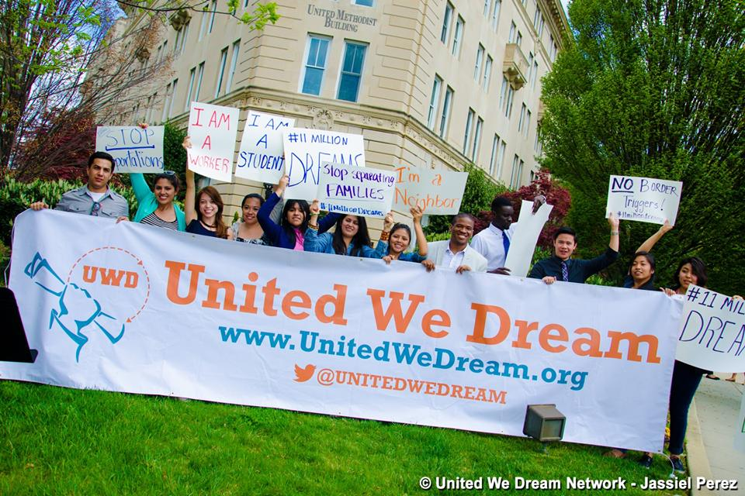

It may seem somewhat presumptive, but I believe that undocumented immigrants are in fact the epitome of a counterpublic as defined by Michael Warner. He states,

“A counterpublic maintains at some level, conscious or not, an awareness of its subordinate status… the discourse that constitutes it is not merely a different or alternative idiom, but one that in other contexts would be regarded with hostility, or with a sense of indecorousness. Like all publics, a counterpublic comes into being through an address to indefinite strangers...but counterpublic discourse also addresses those strangers as being not just anybody. They are socially marked by their participation in this kind of discourse; ordinary people are presumed not to want to be mistaken for the kind of person that would participate in this kind of talk, or to be present in this kind of scene” (423-424).

United We Dream calls attention to a group of people who are not otherwise accepted in society, so they emerge as a counterpublic. UWD and the youth who actively participate are “using digital media to build a national movement for immigrant rights against great political, legal, economic, and technological barriers” (Gamber Thompson and Zimmerman 186). UWD has created a counterpublic for the dreamers. *Dreamers* are “a” public, but not “the” public. They are an unwelcome, subversive public, and they challenge the status quo and introduce friction into the machine, causing a disruption to the normal public. Leah Perry writes, “A person's status itself is the offense… and therefore the term ‘illegal alien’ invokes the nonhuman status of aliens from outer space” (59). In many cases, *dreamers* have been shamed and cast out of public spaces and places because, to many, they are considered not to be part of the conversation because they are not considered citizens, not legally in America, undocumented. Many undocumented, particularly Latino immigrants, are still feared and perceived in a negative light as the “other,” and they face “discrimination, racial profiling, civil rights violations, scape-goating, hate-crimes, and a public discourse that demonizes immigrant outsiders. In many areas, Latino immigrants are the “new Blacks,” having been stereotyped and stigmatized as the perennial and inassimilable underclass” (Davies 378).  To further explain, “borders are not just physical or geographical: they are also mental...” It is at this nexus of confrontation with the “alien *other*” that society is grappling with when it comes to facing an ethical dilemma of acceptance (or nonacceptance) (Davies 386). It has led to distrust of the American educational, legal, and political system: a distrust of everything American.  As a result, UWD and *dreamers* created their own publics through their language and vernacular; and therefore, United We Dreamhas called into existence through writing, speaking, and emotion, the undocumented public. UWD is helping the undocumented navigate the pathway to citizenship through disrupting the narrative of illegal immigrants by highlighting who they are. UWD does this through sharing personal experiences and celebrating cultures with those who can relate. These types of online participatory practices (amplifying their voices through blogs, podcasts, and videos: sharing stories, experiences, movements) create an emergence of activism for both those who are participating and those who are listening and receiving the messages. It is 21 century civil rights activism (Gamber Thompson and Zimmerman 187).

The bottom line: if 65,000 undocumented immigrants graduate each year, maybe this country should take into consideration what T. Alexander Aleinikoff, Dean of Georgetown University Law Center and Executive Vice President of Georgetown University suggested (in 2001) we should: move toward legalization of the undocumented who are established and working… allowing them to assimilate into and participate in the communities where they live… and allow them to become fully entitled members of this nation (Aguirre, Jr. 7). I believe that United We Dream has created a website equipped with literacy sponsorship to do just that, provide the undocumented immigrants the tools to citizenship, and the opportunity to give back to the society that has educated them by becoming contributing members of society. UWD performs its duties as assigned by The Declaration of Human Rights, Article 29 (1): Everyone has duties to the community in which alone the free and full development of his personality is possible (United Nations). Ultimately, UWD took on its the responsibility to the place (space) in which it resides, and to the people who reside in that place/space, to share knowledge of human rights, by watching out for each other and advocating for those rights. And, immigration is a human right. And, just as Brian Street says, social change involves challenging (and disrupting) a given form of dominant discourse and the production and assertion of other discourses within new material conditions (Street 441).

As future educators, fighting for social justice, what can you do? You can educate yourselves and others around you by: enrolling in United We Dream’s National Institutions Coming Out Day (NICOD) and teach immigrant rights. You can go public and let undocumented immigrants know where you stand (#UnafraidEducator), and advocate for specific students and their families. You can support organizations and activists by offering financial support and help build a rapid response team. You can use your voice to be heard by mobilizing your privilege to speak up and speak out for undocumented immigrants, and make a plan in case ICE shows up at your school. Finally, you can build a community of support by joining your voice with others, and advocate for district policies that safeguard students (Delacroix and Dillard 46).

Works Cited

*A Guide to the Immigration Accountability Executive Action.* American Immigration Council, November 30, 2014. [www.americanimmigrationcouncil.org/research/guide-immigration-accountability-executive-action](http://www.americanimmigrationcouncil.org/research/guide-immigration-accountability-executive-action). Accessed 05 Nov. 2018.

Aguirre, Adalberto. “Immigration on the Public Mind: Immigration Reform in the Obama Administration.” *Social Justice*, vol. 35, no. 4 (114), 2008, pp. 4–11. *JSTOR*, JSTOR, [www.jstor.org/stable/29768511](http://www.jstor.org/stable/29768511).

Arroyo, Sarah. 2013. [*Participatory Composition: Video Culture, Writing, and Electracy*](https://smile.amazon.com/Participatory-Composition-Culture-Writing-Electracy/dp/0809331462/ref=sr_1_1?s=books&ie=UTF8&qid=1533832738&sr=1-1&keywords=participatory+composition). Carbondale: Southern Illinois UP.

Bartholomae, David. “Inventing the University,” [*Literacy: A Critical Sourcebook*](https://smile.amazon.com/Literacy-Critical-Sourcebook-Ellen-Cushman/dp/0312250428/ref=sr_1_cc_1?s=aps&ie=UTF8&qid=1533832271&sr=1-1-catcorr&keywords=literacy+critical+sourcebook)*,* edited by Cushman, Ellen, et al., Bedford/St. Martin’s, 2001, pp. 511-524.

Brandt, Deborah and Clinton, Katie. “Limits of the Local: Expanding Perspectives on Literacy as a Social Practice.” *Journal of Literary Research*. V.34, No. 3, 2002, pp. 337-356. [doi.org/10.1207/s15548430jlr3403_4](https://doi.org/10.1207/s15548430jlr3403_4). Accessed 21 August 2018.

Bridgman, Katherine. “Overcoming the Limitations of Shared Digital Spaces: Twitter in the Egyptian Revolution of 2011.” *Connexions International Professional Communication Journal*. pp. 1-25, 2018. [connexionsj.files.wordpress.com/2018/07/2018_resa_bridgman.pdf](https://connexionsj.files.wordpress.com/2018/07/2018_resa_bridgman.pdf).

Candelaria Green, Jamie. “Misperspectives on Literacy: A Critique of an Anglocentric Bias in Histories of American Literacy,” [*Literacy: A Critical Sourcebook*](https://smile.amazon.com/Literacy-Critical-Sourcebook-Ellen-Cushman/dp/0312250428/ref=sr_1_cc_1?s=aps&ie=UTF8&qid=1533832271&sr=1-1-catcorr&keywords=literacy+critical+sourcebook)*,* edited by Cushman, Ellen, et al., Bedford/St. Martin’s, 2001, pp. 234-243.

Castells, Manuel. 2015 (2012). [*Networks of Outrage and Hope: Social Movements in the Internet Age. 2nd Ed*](https://smile.amazon.com/Networks-Outrage-Hope-Movements-Internet-ebook/dp/B00Z0JADXK/ref=mt_kindle?_encoding=UTF8&me=&qid=1533831664). Cambridge: Polity Press.

Cohn, D’Vera, et. al. *5 Facts about illegal immigration in the U.S.* Pew Research Center, April 27, 2017, [www.pewresearch.org/fact-tank/2017/04/27/5-facts-about-illegal-immigration-in-the-u-s/](http://www.pewresearch.org/fact-tank/2017/04/27/5-facts-about-illegal-immigration-in-the-u-s/). Accessed 08 Nov. 2018.

Davies, Ian. “Latino Immigration and Social Change in the United States: Toward an Ethical Immigration Policy.” *Journal of Business Ethics*, vol. 88, 2009, pp. 377–391. *JSTOR*, JSTOR, [www.jstor.org/stable/27749711](http://www.jstor.org/stable/27749711).

Delacroix, Julia and Dillard, Coshandra. “This is Not a Drill.” *Teaching Tolerance*, Fall 2018, issue 60, pp. 46-48.

Dillard, Coshandra. “The School to Deportation Pipeline.” *Teaching Tolerance*, Fall 2018, issue 60, pp. 42-45.

Gamber-Thompson, Liana and Zimmerman, Arely M. “Undocumented Youth, Coming out, and Pathways to Participation,” [*By Any Media Necessary: The New Youth Activism*](https://smile.amazon.com/Any-Media-Necessary-Activism-Connected/dp/1479899984/ref=sr_1_1?s=books&ie=UTF8&qid=1533830654&sr=1-1&keywords=by+any+media+necessary). Edited by Jenkins, Henry, et al. 2016.  New York: NYU Press. Pp. 186-218.

*Immi: Free and Simple Information for Immigrants*. Pro Bono Net, 2018. <https://www.immi.org/es>. Accessed 31 Oct. 2018.

Krogstad, Jens Manuel, and Lopez, Gustavo. *Key Facts about unauthorized immigrants enrolled in daca*. Pew Research Center, September 25, 2017, [www.pewresearch.org/fact-tank/2017/09/25/key-facts-about-unauthorized-immigrants-enrolled-in-daca/](http://www.pewresearch.org/fact-tank/2017/09/25/key-facts-about-unauthorized-immigrants-enrolled-in-daca/). Accessed 08 Nov. 2018.

Krogstad, Jens Manuel, senior writer. *DACA has shielded nearly 790,000 young unauthorized immigrants from deportation.* Pew Research Center, September7, 2017, [www.pewresearch.org/fact-tank/2017/09/01/unauthorized-immigrants-covered-by-daca-face-uncertain-future/](http://www.pewresearch.org/fact-tank/2017/09/01/unauthorized-immigrants-covered-by-daca-face-uncertain-future/). Accessed 08 Nov. 2018.

Lankshear, Colin, and Knobel, Michele. 2011. [*New Literacies: Everyday Practices and Social Learning, 3rd Ed*](https://smile.amazon.com/New-Literacies-Everyday-Practices-Learning/dp/0335242162/ref=pd_sbs_14_1?_encoding=UTF8&pd_rd_i=0335242162&pd_rd_r=TSRX5HYV1M8ZMZ6X7DRW&pd_rd_w=eevc7&pd_rd_wg=bEafo&psc=1&refRID=TSRX5HYV1M8ZMZ6X7DRW). London: Open University Press.

Mohamed, Heather Silber. “From Assimilation to Nationalism to ‘We Are America’: Immigration Law, Social Movements, and Identity Frames, 1900s–2006.” *The New Americans?: Immigration, Protest, and the Politics of Latino Identity*, University Press of Kansas, 2017, pp. 34–65. *JSTOR*, [www.jstor.org/stable/j.ctt1mtz77k.7](http://www.jstor.org/stable/j.ctt1mtz77k.7).

Passell, Jeffrey S, and Cohn, D’Vera. *As Mexican share declined, US unauthorized immigrant population fell in 2015 below recession level.* Pew Research Center, April 25, 2017. [www.pewresearch.org/fact-tank/2017/04/25/as-mexican-share-declined-u-s-unauthorized-immigrant-population-fell-in-2015-below-recession-level/](http://www.pewresearch.org/fact-tank/2017/04/25/as-mexican-share-declined-u-s-unauthorized-immigrant-population-fell-in-2015-below-recession-level/). Accessed 08 Nov. 2018.

Perry, Leah. “Neoliberal Crimmigration: The ‘Commonsense’ Shaming of the Undocumented.” *American Shame: Stigma and the Body Politic*, edited by MYRA MENDIBLE, Indiana University Press, 2016, pp. 57–83. *JSTOR*, [www.jstor.org/stable/j.ctt1bmzmdz.7](http://www.jstor.org/stable/j.ctt1bmzmdz.7).

Resource Guide: “Supporting Undocumented Youth: A Guide for Secondary and Post-Secondary Settings.” *United States Department of Education*. 15 October 2018. [www2.ed.gov/about/overview/focus/supporting-undocumented-youth.pdf](https://www2.ed.gov/about/overview/focus/supporting-undocumented-youth.pdf). Accessed 12 November 2018.

Sarafini, Frank, and Gee, Elisabeth. 2017. [*Remixing Multiliteracies: Theory and Practice from New London to New Times*](https://smile.amazon.com/Remixing-Multiliteracies-Practice-Language-Literacy/dp/0807758647/ref=sr_1_1?s=books&ie=UTF8&qid=1533832852&sr=1-1&keywords=remixing+multiliteracies). New York: Teachers College Press.

Stornaiuolo, Amy, et al. “Developing a Transliteracies Framework for a Connected World.” *Journal of Literacy Research*, vol. 49, no. 1, Mar. 2017, pp. 68–91, doi:[10.1177/1086296X16683419](https://doi-org.jproxy.lib.ecu.edu/10.1177/1086296X16683419).

Street, Brian. “The New Literacy Studies,” [*Literacy: A Critical Sourcebook*](https://smile.amazon.com/Literacy-Critical-Sourcebook-Ellen-Cushman/dp/0312250428/ref=sr_1_cc_1?s=aps&ie=UTF8&qid=1533832271&sr=1-1-catcorr&keywords=literacy+critical+sourcebook)*,* edited by Cushman, Ellen, et al., Bedford/St. Martin’s, 2001, pp. 430-442.

Stuckey, J. Elspeth. 1991. [*The Violence of Literacy*](https://smile.amazon.com/Violence-Literacy-HEINEMANN-OP/dp/086709270X/ref=sr_1_1?s=books&ie=UTF8&qid=1533832358&sr=1-1&keywords=the+violence+of+literacy). Portsmouth: Boynton-Cook.

*The Dream Act, DACA, and Other Policies Designed to Protect Dreamers.* American Immigration Council, September 6, 2017. [www.americanimmigrationcouncil.org/research/dream-act-daca-and-other-policies-designed-protect-dreamers](http://www.americanimmigrationcouncil.org/research/dream-act-daca-and-other-policies-designed-protect-dreamers). Accessed 05 Nov. 2018.

United Nations: Universal Declaration of Human Rights. [www.un.org/en/universal-declaration-human-rights/](http://www.un.org/en/universal-declaration-human-rights/). Accessed 17 November 2018.

*United We Dream*. United We Dream, 2018, <https://unitedwedream.org/>. Accessed 29 Oct. 2018.

Warner, Michael. “Publics and Counterpublics (Abbreviated Version).” *Quarterly Journal of Speech* 88.4 (2002): 413–425. Web. [www.tandfonline.com/doi/abs/10.1080/00335630209384388#aHR0cHM6Ly93d3cudGFuZGZvbmxpbmUuY29tL2RvaS9wZGYvMTAuMTA4MC8wMDMzNTYzMDIwOTM4NDM4OD9uZWVkQWNjZXNzPXRydWVAQEAw](http://www.tandfonline.com/doi/abs/10.1080/00335630209384388#aHR0cHM6Ly93d3cudGFuZGZvbmxpbmUuY29tL2RvaS9wZGYvMTAuMTA4MC8wMDMzNTYzMDIwOTM4NDM4OD9uZWVkQWNjZXNzPXRydWVAQEAw). Accessed 23 October 2018.

Welch, Nancy. 2008. [*Living Room: Teaching Public Writing in a Privatized World*](https://smile.amazon.com/Living-Room-Teaching-Writing-Privatized/dp/0867095849/ref=sr_1_1?s=books&ie=UTF8&qid=1533832416&sr=1-1&keywords=living+room+welch). Portsmouth: Boyton-Cook.