Emily Tucker
Dr. Banks
ENGL 8600
5 December 2018
What Would Mickey Do?:
The Walt Disney Company’s Response to Tragedy in the Community
Thousands upon thousands of guests visit the Disney theme parks each year. The Walt Disney Company, and particularly the theme park branch of this entertainment corporation, has built itself on this idea of total and complete happiness. It is, after all, the happiest place on earth. Disney has stood the test of time and built its brand on exceptional guest service. When employees (what Disney terms as “cast members”) begin their career with the company, each person must take a required course on their first day entitled “Traditions” which discusses the history and culture of the company. Preservation is imperative to The Walt Disney Company. Nearly everything within the theme park side of the business is built on the idea of “The Four Keys” – safety, courtesy, show, and efficiency – and in that particular order. (I want to take a moment to explain the use of Disney company jargon within my work and situate these terms before going any further. The term “cast member” is used to describe an employee of The Walt Disney Company. Walt Disney built the company, and especially the theme parks on the idea that employees were “onstage” when they were working in their “roles,” therefore the terminology surrounding the workplace is focused on a stage performance. Additionally, the term “guest” is used to refer to someone who visits the theme parks, and in company literature is always capitalized to add emphasis and importance, as the guest is valued.) In terms of communications, the Disney company distributes and communicates internally (cast member to cast member) through numerous publications including a magazine titled Eyes and Ears. The Disney company/theme parks also communicate with the public, which going forward I refer to as external (meaning from within the company – cast member – to public – guest).
Walt Disney World operates as a city within itself with its own fire department, shopping, dining, accommodations, and entertainment. As a cast member or guest, it would be easy to never have to remove yourself from what people consider the “Disney bubble.” While this “Disney bubble” is a magical place to be, inevitably reality does begin to set in. The two American Disney theme parks are located in mid-to-large cities – Anaheim, California and Orlando, Florida (Walt Disney World carries the address of Lake Buena Vista, Florida which is a suburb of Orlando, but for our purposes, I will refer to Walt Disney World within the larger Orlando area). Walt Disney World and Disneyland run like small cities within themselves, but also make up a small part of a much larger community which they contribute to.
The year 2016 was a tragic and upsetting one for the greater Orlando area, as within the period of about one week it saw the murder of singer Christina Grimmie, the Pulse nightclub shooting, and the death of Lane Graves due to an alligator attack. The Pulse nightclub shooting, and the death of Lane Graves had direct ties to Walt Disney World. On the night of June 12, Pulse, a gay nightclub in Orlando was attacked by gunman Omar Mateen. Mateen killed 49 people in what was, at the time, the deadliest mass shooting in United States history (“Deadliest Mass Shootings”). Of the 49 victims, one was a current Disney cast member at the time (Bevil). In the wake of this tragic event, Orlando came together as a community to support the victims and their families. As a member of the Orlando community at this time, I can attest to the fact that nearly everywhere you turned, there was a spirit of community. During a trip to a large shopping mall in the Orlando area later that week, there were rainbow flag displays in nearly every anchor department store, with most stores actually redesigning their windows and entrances in order to add flags and remembrances honoring the LGBTQ+ community and those who lost their lives at Pulse. With the response being so strong from the surrounding community, Disney also needed to get involved to offer its support to the victims, and their friends and families. With 49 victims and nearly 75,000 cast members, the likelihood that friends and family of the victims were Disney cast members was also extremely likely.
The death of Lane Graves had a vastly different, although still tragic impact on the theme park and the company. Just days after the Pulse nightclub shooting, Lane Graves, a two-year old boy and his family, were spending time on the beach at Disney’s Grand Floridian Resort and Spa when Lane was attacked by an alligator. The beach at the resort hosts a long sandy area that meets some marshy water. Around 9:00pm, Lane was attacked by an alligator who presumably lived in that body of water that overlooks the Magic Kingdom theme park. Despite his father’s efforts to save him, Lane was killed. The news hit Twitter more quickly than Disney would have liked (as they would have like to have been able to control and make a statement along with this news) and the call for more safety protocols from Disney soon followed. Since that time, there has been much speculation about who is to blame in this situation – is it Disney for not putting up proper safety signs, or is it the family’s for letting Lane go into unknown water that had a no swimming sign and is located in one of the swampiest states in America? While there is no clear-cut and decisive answer to this question, Disney’s response from the top down speaks to the literacy of the company, especially in how they handle the aftermath of those things that are less than Disney-like.
In this paper, I will explore the history and literacies used by Disney to respond to tragedies in the community and on their own property. Through looking at how executives and cast members have (or have not) responded to tragedies beginning with Walt Disney himself through 9/11 and eventually ending up with the attack of Lane Graves, I hope to see how these literacies are used to a) continue to uphold the reputation of the company and 2) make a true impact on the lives of the affected people, and 3) compare and contrast how the response to these events were portrayed across various theme park blogs and external communications (those not having any official connection to the company). Furthermore, I will also analyze some of the publications by Disney within internal (cast member to cast member) and external (cast member to guest) communications noting these events and supporting larger organizations.
History
Walt Disney’s dream was realized when he opened Disneyland in Anaheim, California in 1955 (History.com Editors). Disney did not live to see the opening of the Magic Kingdom, the first park to open in 1971 in Orlando, Florida. Disney did, however, experience tragedy to his empire even prior to either park’s opening day. Walt and his brother Roy created what is now the Walt Disney Studio in Burbank, California in 1926 (formerly the Disney Brothers Studio) (Amernic and Craig 88). In 1940 with the war happening, the studio created its first letter to its stockholders, thought to be written by Walt and Roy Disney. Joel Amernic and Russell Craig, regarding the shareholder letter, assert that, “The first sentence – ‘The effect of the war in Europe upon the affairs of your Company has been serious and the full measure thereof cannot yet be determined’” (94). Here the Disney brothers instill pride and ownership in the company to those shareholders – it is their company. The authors go on to write, “Disney refers to ‘the’ company forty-four times in the letter. Only once, and in this section, does he refer to ‘your’ company. In doing so, he brings home the implications of the bad news to shareholders” (94). The idea of the war as something impacting others was not something Walt Disney thought to address in this letter, rather working for the need of the company. However, based on the Four Keys and the culture around the Disney company to this day by cast members and fans alike, it seems as though these values were originally put in place by Walt’s company-first attitude.

September 11, 2001
September 11, 2001 remains to be considered one of the most sobering and affecting days in modern United States history. Walt Disney World opened that morning, as it did the many other mornings before that day. As the news of the attacks came in, the Walt Disney World (and Disneyland although they had not opened due to the time difference) decided to close for the day thinking they could potentially be a target for a large-scale terrorist attack themselves. The cast members were asked to evacuate the Guests from the parks, and Disney parks were closed for the day (Figure 6). This has only happened a few times since the opening of Disneyland in 1955 and Walt Disney World in 1971 – the blog Disney Dorks notes that it happened at Disneyland for the assassination of John F. Kennedy, and at Walt Disney World for Hurricane Floyd (Nate).
Jim Hill, in his article for the Huffington Post titled “What Was It Like at Walt Disney World on 9/11” points out that Disney “has never officially commented on what exactly happened in Anaheim & Orlando on September 11, 2001.” Internally though, it has been reported that Michael Eisner, Chairman and CEO at the time, addressed a statement to cast members reading, “’Finally let me say our company around the world will continue to operate in this sometimes violent world in which we live, offering products that reach to the higher and more positive side of the human equation’” (Dixon). We see a shift in the way this tragedy was responded to by Eisner as compared to the response by Walt Disney to shareholders. While it can be said that the audience and purpose for these statements was vastly different, the idea of the company-first attitude that we see in Walt Disney’s statement is nowhere to be found in Eisner’s. Rather we see the head of a company promising the Guest satisfaction. (This can be problematic too, as we know that Eisner’s Guest first reaction only may be motivated by more product sales…but that’s a topic for a different article.)

June 2016 & Reactions in the Digital Age
In our post-9/11 world, technology takes up much more space than it did before. Technology and social media have infiltrated our lives. Two of the ways we see this in reaction to tragedies by Disney is through these technologies – specifically through Twitter and through unofficial park blog sites. I looked at four various Twitter accounts to gather information about what messages were posted in response to the Pulse nightclub shooting:
- @Disney – “The official Twitter for Disney”
- @WaltDisneyWorld – “The official Twitter feed for the Walt Disney World Resort”
- @robertiger – “Chairman and CEO The Walt Disney Company”
- @WDWToday – “The official in-park Twitter feed for @WaltDisneyWorld live updates & answers”
Sifting through the feeds from May 2016 to October 2016, I found only one instance on the @WaltDisneyWorld feed (Figure 1) and one specifically on the @WDWToday feed (Figure 2). What I did note though was the @WDWToday feed stayed silent from June 11 to June 14. On June 23, @WDWToday tweeted an inspirational Walt Disney quote and picture of the theme park (Figure 3).
While there were no mentions of either of the June 2016 tragedies on the Twitter feed of Robert Iger, Disney’s Chairman and CEO, there were official statements released to the public from the Iger. WESH 2 News online posted an article with his response at 5:29p.m. on June 12, 2016. Iger said, “We are all heartbroken by the tragic and horrific events in Orlando, and offer our thoughts, prayers and support to everyone in our community affected by this senseless act” (“Disney CEO Bob Iger”). Internally, Disney blogging site “The Laughing Place” reported the George Kalogridis, the President of Walt Disney World, released a letter commemorating the one-year anniversary of the attacks. One of his most powerful statements comes when he writes, “Our colleagues in The Walt Disney Company, across the nation and around the world, reached out in empathy. And we were not alone – all of Central Florida reacted to ugliness and hate with beauty and compassion and with love” (Laughing Place Disney Newsdesk). Kalogridis goes on in his letter to tell cast members that he has been asked to serve on the OnePULSE foundation board and has accepted. This political awareness, combined with the fact that Kalogridis is Walt Disney World’s first openly gay President himself, illustrates the movement toward political awareness and change that the company is making.
Iger also released a statement regarding the death of Lane Graves, saying, “As a parent and a grandparent, my heart goes out to the Graves family during this time of devastating loss. My thoughts and prayers are with them, and I know everyone at Disney joins me in offering our deepest sympathies” (Snierson). Kalogridis echoed Iger’s sentiments in his statement, “There are no words to convey the profound sorrow we feel for the family and their unimaginable loss. We are devastated and heartbroken by this tragic accident and are doing what we can to help them during this difficult time. On behalf of everyone at Disney, we offer them our deepest sympathy” (Snierson). It has also been reported that Iger and Kalogridis were both in Shanghai for the opening of Shanghai Disneyland when the alligator attack occurred, and that Kalogridis was on a flight back to Orlando as soon as he heard the news (Stelter). Upon searching for Lane Graves as a keyword on Twitter including the same accounts, no results were found (Figure 7, 8, 9, 10) for either search term “Lane Graves” or “Graves.”
There were, however two new additions to the Walt Disney World property in response to Lane Graves’s death. The first, warning signs of potentially harmful wildlife living in the water near the resort area (this resort area is home to Disney’s Polynesian Village Resort, Disney’s Grand Floridian Resort and Spa, and Disney’s Contemporary Resort) (Figure 4). The second was a lighthouse statue commemorating the life of Lane Graves (Figure 11) (Hayes). These additions served as forms of visual rhetoric warning against potential danger and celebrating the life of a young child lost to that danger. We can see distinctions drawn between these two though – the warning signs were way overdue, as dangerous wildlife had been living in this marshy area for years, and the memorial was just on time and a well-planned and curated response by Disney.
Disney’s official word is always carefully curated and well-planned, but the response from the unofficial Disney community sometimes shows vastly different opinions or values. Unofficial theme park blogging sites have become extremely popular over the past few years. Often times, these blogs are run by Disney fans, and by those who do not work for the company but are annual passholders. Sometimes these blogging sites offer travel planning services for trips to Disney theme parks. Content ranges from restaurant reviews to discussion boards and nearly every Disney question or concern in between. While many of these bloggers, especially those who work as travel planners, are paid by Disney for their planning work, they still have the flexibility and freedom to be critical in their assessment and reviews of decisions made on behalf of the Disney company. For this analysis, I looked at four major Disney blogs – The DIS Disney Blog, Disney Tourist Blog, Chip and Company, and Inside the Magic. To gather this information, I used the search bar on each of the sites and the keywords “Pulse” and “Lane Graves.” With the returned results, I used the title and keywords from the article to determine whether or not each article pertained to the specific incident addressed within this work.
A search for “Pulse” on these blogs yields these results:
- The DIS Disney Blog – 20
- Disney Tourist Blog – 0
- Chip and Company – 5
- Inside the Magic – 6
I completed the same with the search term “Lane Graves” and found:
- The DIS Disney Blog – 28
- Disney Tourist Blog – 0
- Chip and Company – 4
- Inside the Magic – 5
In Henry Jenkins’s works, Fans, Bloggers, and Gamers: Exploring Participatory Culture, he asserts that “…the blogging community continues to challenge the mainstream news media…” (2). We see examples of this in the way these unofficial Disney blogs discussed these tragedies much more than and in different ways than the company did.
Henry Jenkins, Sam Ford, and Joshua Green discuss the idea of “spreadability” in their work saying, “Spreadability recognizes the importance of the social connections among individuals, connections increasingly made visible (and amplified) by social media platforms” (6). Disney blog examples offer a strong example of that. Unofficial Disney blogs are shared and passed about the Internet doing the work of raising awareness and spreading news, events, and reactions. So many of these things are shared that Disney does not have to officially engage in this work, as others are doing it for them. Jenkins, Ford, and Green go on to say that “…content generated and spread through the digital gift economy is also eventually used directly by companies as promotional material” (86). This is demonstrated through many of the unofficial drawings and animations that are shared on social media from Disney fans during tragedies. For example, two particular drawings circulated after Pulse – one of Mickey Mouse sitting on a stool crying (Figure 12), and the other the backs of Peter Pan, Snow White, and Alice (in Wonderland) embracing each other surrounded by the background of a rainbow flag (Figure 13). This was most recently observed in during the death of renowned cast member Richard who was known by cast members and Guests alike as the greeter at Disney’s Grand Floridian. Many cartoons circulated remembering the work and impact Richard made on people at Walt Disney World (Figure 14) and George Kalogridis even made a public statement about his death.
Theoretical Frameworks + Analysis
One of the major frameworks we see in play in these situations are the ones Henry Jenkins, Sangita Shresthova, Liana Gamber-Thompson, Neta Klinger-Vilenchik, and Arely M. Zimmerman discuss in their work By Any Media Necessary: The New Youth Activism. The authors write, “Even painted in broader strokes, one can see an ongoing process through which young people have refreshed and renewed the public’s symbolic power as they fight for social justice; they often push back against inherited forms and search for new mechanisms for asserting their voice” (2). We see this in the way the cast members responded to the Pulse shooting. While what Iger and Kalogridis released were poignant, the response from young cast members was perhaps the most astounding. Individual areas of the theme park started bringing their cast member teams together take photos of support for the victims and their families (Figure 5). Jenkins et al. go on to say that “Thus a more playful style of activism is emerging through this appropriative and transformative dimension of participatory culture” (2). Not only do we see “participatory culture” in the way cast members respond to tragedy, but we also see it reiterated in Kalogridis’s reaction by joining the OnePULSE foundation. In stark contrast to Walt’s purposeful rhetorical choices of the “your company” versus “the company,” movement toward more investment in current events and social activism has infiltrated leadership of the company since pre-9/11 (but especially post-2016).
Results + Conclusion
Douglas Brode, in his book From Walt to Woodstock: How Disney Created the Counterculture, refutes many of the negative connotations held by those in academia of Walt Disney and the work of the company. He writes:
The demeaning reputation of Disney as superficial – compounded by the commercial success of his work more than thirty-five years after the man’s passing, which in some corners only adds to the reprehensibility of his image – fails to hold up under close scrutiny of his output. That no one has seriously challenged the perception of Disney merely attests that such a negative assessment is considered not a perception but reality (12).
According to Reputation Institute, Disney continues to be ranked highly as a reputable company inside and outside of the entertainment industry – appearing as such in Forbes magazine (“Disney Ranks High”). In their article, Young and Park assert that:
Company credibility mediated the effect of strategy on crisis outcomes, including crisis responsibility, reputation, and behavioral intentions. The company was perceived as more credible when the accommodative strategy was used than when the defensive strategy was used. A higher level of company credibility, in turn, reduced perceived crisis responsibility of the organization, as well as positively affecting organizational reputation and supporting behavioral intention toward the organization (86).
With Disney’s long-standing reputation, it becomes clear that their handling of tragic situations, along with their placement as one of the world’s most reputable companies positions them in such a way that doing this social justice work is not totally necessary. The Disney brand does not have to do this work – they have already established themselves as a company that consumers want a piece of. Rather, they do this work because they are passionate about it. They do this work because they choose to. They do this work because they believe in it (although it has not always been that way).
John M. T. Balmer notes, “This perspective regards corporate identities to be active and evolving organisms: their identities are always in the making and are never fully made” (886).
Disney is by no means perfect, although with their reputation are held to an impossible standard. While they are a business, and we are a society bound by capitalism, we can see based on the history of reactions to tragedy that Disney is changing in the modern era, much of that due to young people and politically aware and active leadership.

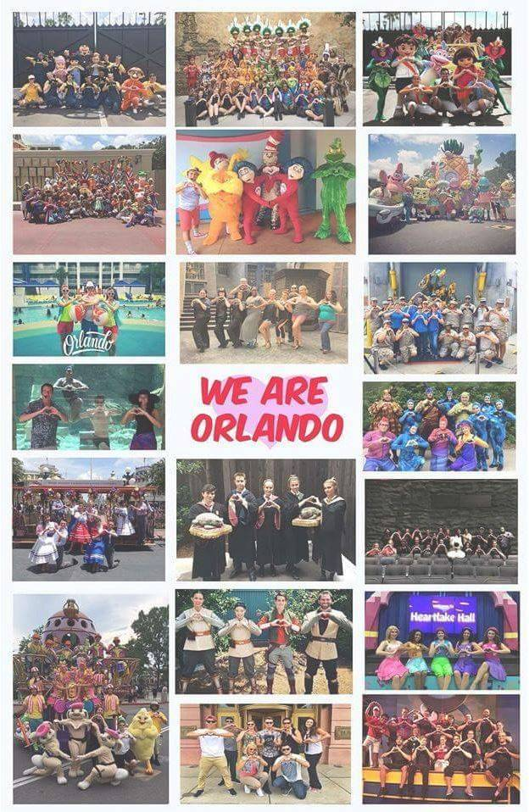
Figure 1
Figure 2
Figure 5

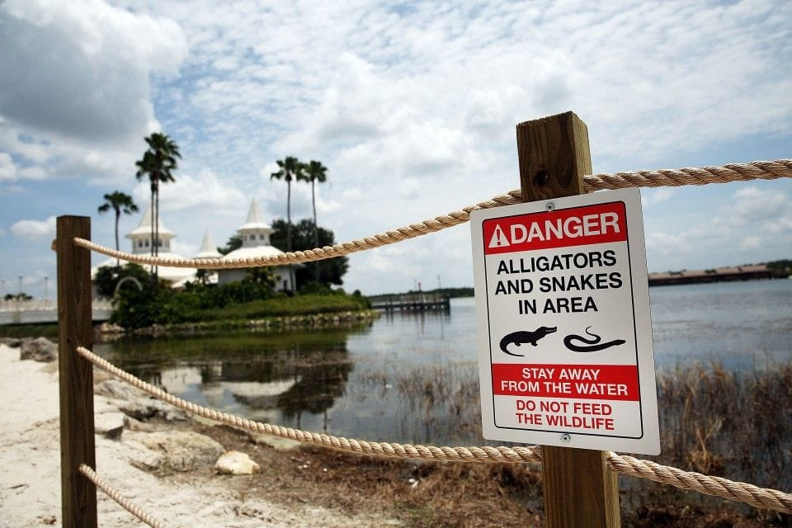
Figure 3
Figure 4

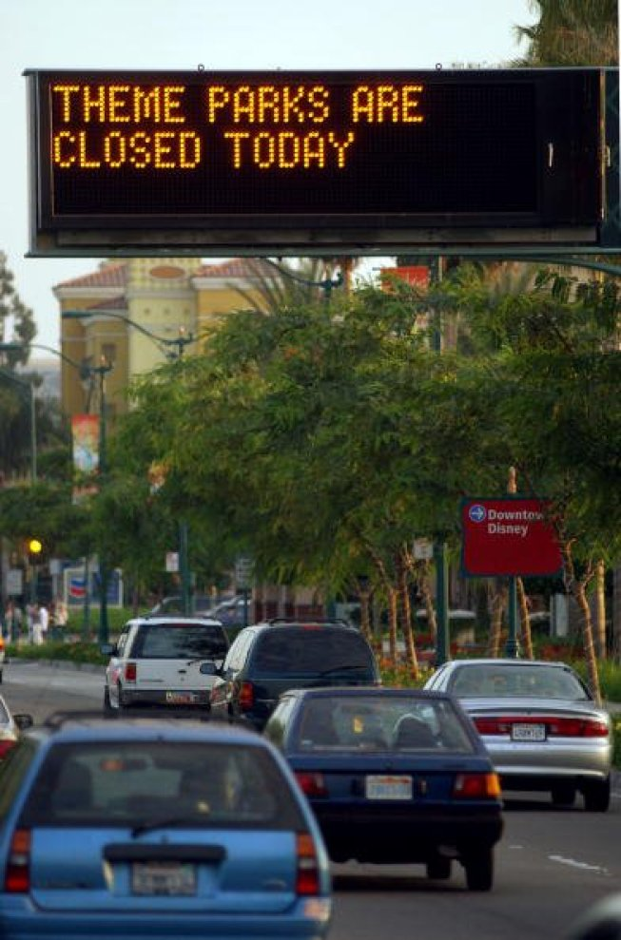
Figure 6
Figure 7

Figure 8

Figure 10
Figure 9
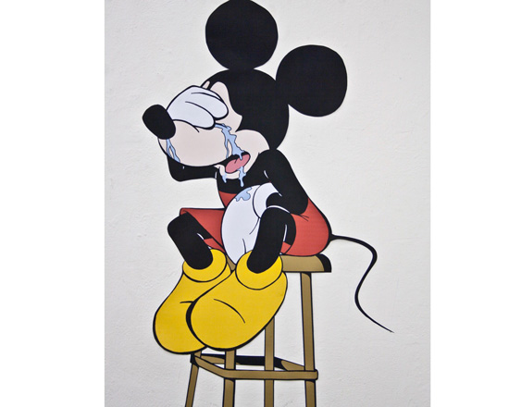
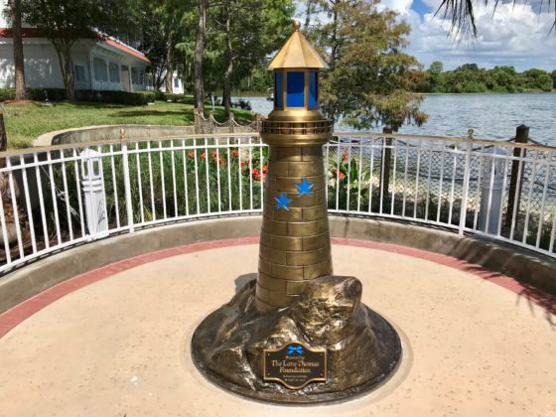
Figure 11
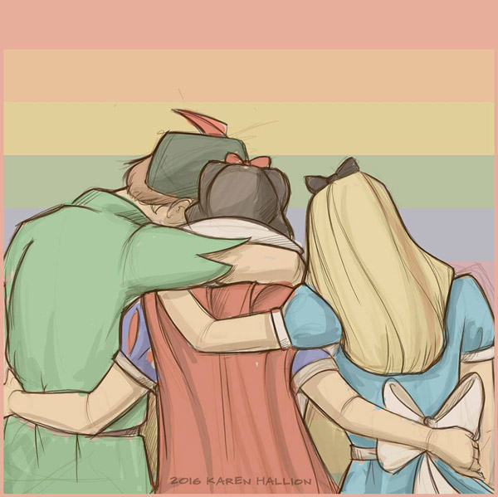
Figure 12
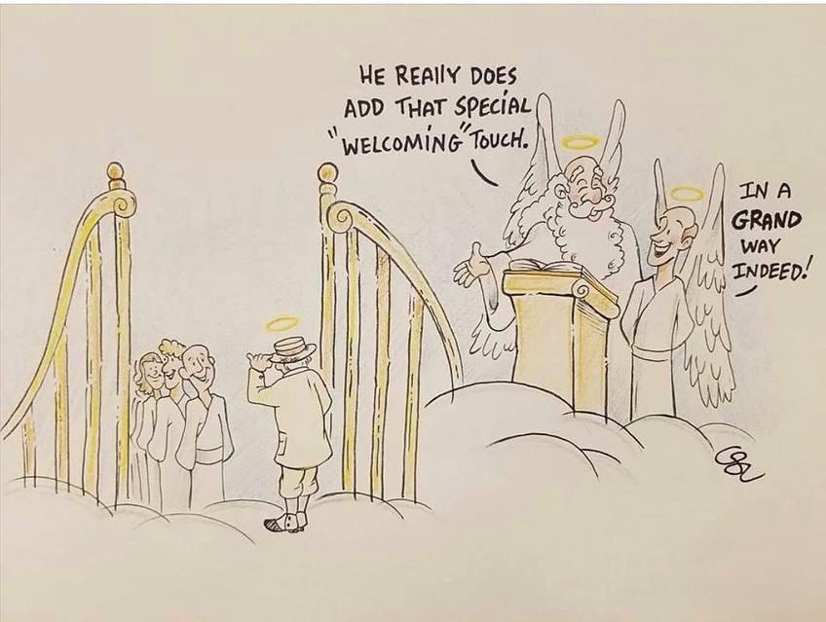
Figure 14
Figure 13

Works Cited

Amernic, Joel, and Russell Craig. CEO-Speak: The Language of Corporate Leadership. McGill-Queen’s University Press, 2006.
Balmer, John M. T. “Identity Based Views of the Corporation: Insights from Corporate Identity, Organisational Identity, Social Identity, Visual Identity, Corporate Brand Identity and Corporate Image.” European Journal of Marketing, vol. 42, no. 9/10, 2008, pp. 879-906.
Bevil, Dewayne. “Remembrance to be held at Disney World.” Orlando Sentinel, 14 June 2016, https://www.orlandosentinel.com/news/pulse-orlando-nightclub-shooting/os-disney-world-vigil-shooting-20160614-story.html.
Brode, Douglas. From Walt to Woodstock: How Disney Created the Counterculture. University of Texas Press, 2004. ProQuest eBook Central, https://ebookcentral.proquest.com/lib/eastcarolina/detail.action?docID=3443020.
“Deadliest Mass Shootings in Modern US History Fast Facts.” CNN, 14 November 2018, https://www.cnn.com/2013/09/16/us/20-deadliest-mass-shootings-in-u-s-history-fast-facts/index.html.
“Disney CEO Bob Iger releases statement on Pulse nightclub shooting.” WESH 2 News, 12 June 2016, https://www.wesh.com/article/disney-ceo-bob-iger-releases-statement-on-pulse-nightclub-shooting/4450099.
“Disney Ranks High on the List of ‘The World’s Most Reputable Companies.’” The Walt Disney Company, 28 February 2017, https://www.thewaltdisneycompany.com/disney-ranks-high-list-worlds-reputable-companies/.
Dixon, Jeff. “Due to Circumstances Beyond Our Control the Magic Kingdom is Now Closed (Remembering Sept. 11, 2001).” Key to the Kingdom, 11 September 2013, http://www.keytothekingdombook.com/wordpress/2013/09/due-to-circumstances-beyond-our-control-the-magic-kingdom-is-now-closed-remembering-sept-11-2001/.
Hayes, Cristal. “Disney World Unveils Statue Honoring Toddler Killed by Alligator.” Orlando Sentinel, 7 August 2017, https://www.orlandosentinel.com/news/breaking-news/os-disney-statue-alligator-lane-graves-20170807-story.html.
History.com Editors. “Disneyland Opens.” History, 21 August 2018, https://www.history.com/this-day-in-history/disneyland-opens.
Hill, Jim. “What Was It Like at Walt Disney World on 9/11.” Huffington Post, 7 September 2011, https://www.huffingtonpost.com/jim-hill/what-was-it-like-at-walt-_b_952645.html.
Jenkins, Henry. Fans, Bloggers, and Gamers: Exploring Participatory Culture. New York: New York University Press, 2006.
Jenkins, Henry, et al. By Any Media Necessary: The New Youth Activism. NYU Press, 2016. EBSCOhost, jproxy.lib.ecu.edu/login?url=http://search.ebscohost.com/login.aspx?direct=true&db=nlebk&AN=1084160&site=ehost-live.
Jenkins, Henry, et al. Spreadable Media: Creating Value and Meaning in a Networked Culture. New York: New York University Press, 2013.
Laughing Place Disney Newsdesk. “Walt Disney World Remembers Victims of Pulse Shooting on #OrlandoUnitedDay.” Laughing Place, 12 June 2017, https://www.laughingplace.com/w/news/2017/06/12/walt-disney-world-remembers-victims-pulse-shooting-orlandounitedday/.
Nate. “Today in Disney History: September 11, 2001 – Disney Parks Close.” Disney Dorks, 11 September 2018, https://mydisneydorks.com/2018/09/11/today-in-disney-history-september-11-2001-disney-parks-close/.
Smith, Thomas. “Statement from the President of Walt Disney World.” Disney Parks Blog, 15 June 2016, https://disneyparks.disney.go.com/blog/2016/06/statement-from-the-president-of-walt-disney-world/.
Stelter, Brian, “Disney’s Bob Iger calls family of boy snatched by alligator.” CNN Business, 16 June 2016, https://money.cnn.com/2016/06/15/media/disney-crisis-bob-iger/index.html.
Snierson, Dan. “Disney execs offer condolences after toddler dies in alligator attack.” Entertainment Weekly, 15 June 2016, https://ew.com/article/2016/06/15/disney-statement-toddler-alligator/.
Young, Kim, and Hyojung Park. "Is there Still a PR Problem Online? Exploring the Effects of Different Sources and Crisis Response Strategies in Online Crisis Communication Via Social Media." Corporate Reputation Review, vol. 20, no. 1, 2017, pp. 76-104. ProQuest, http://search.proquest.com.jproxy.lib.ecu.edu/docview/1891616250?accountid=10639, doi: http://dx.doi.org/10.1057/s41299-017-0016-5.
Images:
(Figure 1) – @WaltDisneyWorld. “’We mourn the loss of the victims & offer our condolences to their families, friends and loved ones.’ -Bob Chapek.” Twitter, 14 June 2016, 11:36a.m., https://twitter.com/WaltDisneyWorld/status/742787734306050048.
(Figure 2) – @WDWToday. “’There’s really no secret about our approach. We keep moving forward…#DisneyQuotes.” Twitter, 23 June 2016, 5:45 a.m., https://twitter.com/WDWToday/status/745960855989325824.
(Figure 3) – @WDWToday. “The Walt Disney Company commits $1 million to the #OneOrlando Fund. Read More: http://di.sn/6012BtJnY.” Twitter, 14 June 2016, 11:31 a.m., https://twitter.com/WDWToday/status/742786571255025664.
(Figure 4) – Platt, Spencer. Disney Wildlife Warning Sign. The Washington Post, Getty Images, 3 November 2017, https://www.washingtonpost.com/news/animalia/wp/2017/11/03/disney-knew-its-park-was-full-of-alligators-it-caught-hundreds-before-a-boy-was-killed/?utm_term=.cd903f0883d6.
(Figure 5) – Pagaran, Michelle. “How the Walt Disney Company and Disney community is responding to the Orlando shooting.” DisneyExaminer, 14 June 2016, http://disneyexaminer.com/2016/06/14/how-the-walt-disney-company-and-disney-community-is-responding-to-the-orlando-shooting/.
(Figure 6) – Nate. “Today in Disney History: September 11, 2001 – Disney Parks Close.” Disney Dorks, 11 September 2018, https://mydisneydorks.com/2018/09/11/today-in-disney-history-september-11-2001-disney-parks-close/.
(Figure 11) – Laughing Place Disney Newsdesk. “Grand Floridian Debuts Lighthouse Sculpture Dedicated to Lane Thomas Graves.” Laughing Place, 7 August 2017, https://www.laughingplace.com/w/news/2017/08/07/grand-floridian-debuts-lighthouse-sculpture-dedicated-lane-thomas-graves/.
(Figures 12 & 13) – Miller, Mark J. “Orlando Brands Respond to Shooting Tragedy at Pulse Nightclub.” Brandchannel, 13 June 2016, https://www.brandchannel.com/2016/06/13/orlando-brands-respond-to-tragedy-061316/.
(Figure 14) – u/Lets_Have_Lunch. “RIP Richard Gerth – art by Diseny artist Jason Zucker.” Reddit, https://www.reddit.com/r/WaltDisneyWorld/comments/8pgsfw/rip_richard_gerth_art_by_disney_artist_jason/.

